Note :

* Before installing make sure that it’s okay to install PyCharm in NTT Laptop.
* Company policies may restrict us to use PyCharm even if its community edition and can be installed manually.
* It still can be used for our practising purposes on personal laptops.
* Company laptops are governed by them, so before installing be aware of this.

After downloading you would get prompt for **User Account Control** , click on **No**

Set the file directory use something like this , or create a folder in C:\

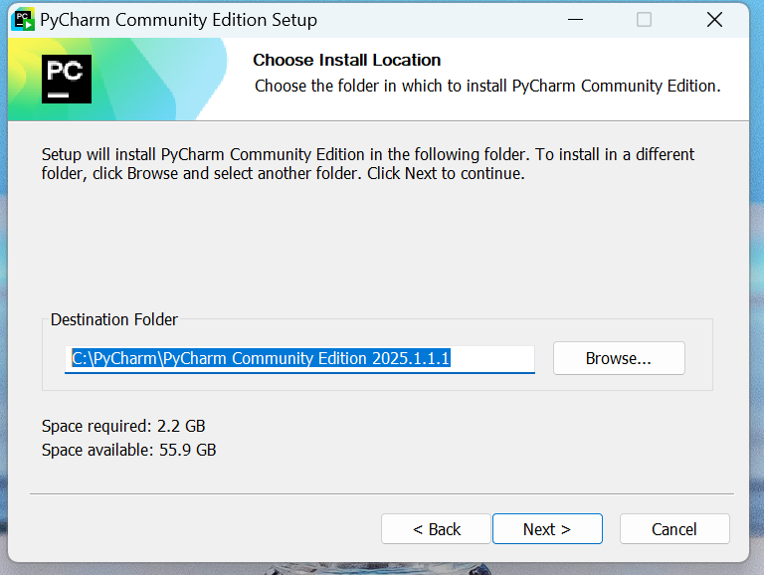

Select options as below

**Skip Add ‘bin’ to PATH – Requires admin privileges ,**

also skip association ( can be done later )

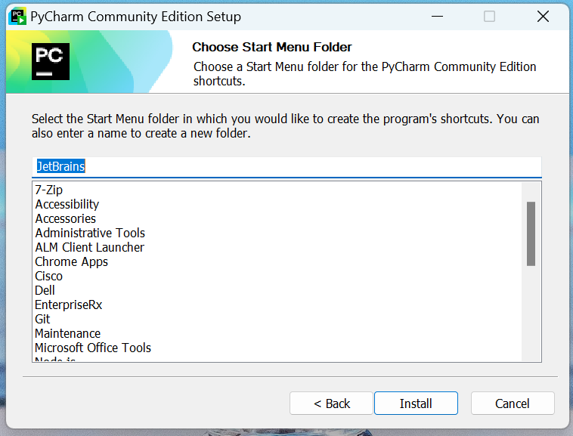

Click on **Install**.